PFP - Labwork 01

Program 1 ( 2 marks)
Write a program that inputs the month and outputs the season of that year.
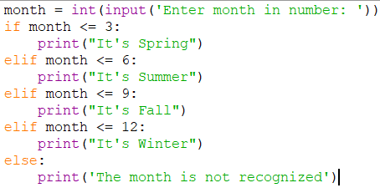

Program 2 (3 marks)
Write a program to accept 3 real numbers a, b, c, then:
- Display the maximum and minimum values among them.
- Arrange them in ascending order, i.e. a ≤ b ≤ c.
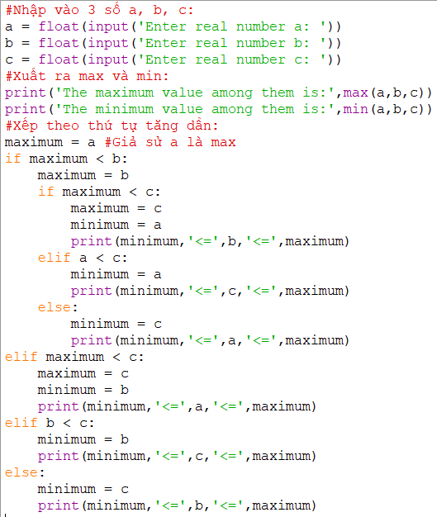

Program 3 ( 5 marks) – Yearly Personal Income Tax

Suppose that:
In Viet Nam, each people has to pay for his/her yearly personal income tax as the following description:

Rules:

Tax-free income:
Personal pending amount (tiền nuôi bản thân) pa= 9 000 000$/month
Alimony (tiền cấp dưỡng) for each his/her dependent pd= 3 600 000$/month/dependent
With n dependents, Yearly tax-free income: tf = 12*(pa + n*pd)

Taxable income (thu nhập chịu thuế)
ti = income – tf
( If ti<=0 then income tax = 0)

Based on taxable income, the employee has to pay his/her income tax with levels pre-defined in the following table:

Level | Taxable Income | Income tax
1 | Less than or equal to 5.000.000 | 5%
2 | From 5.000.001 to 10.000.000 | 10%
3 | From 10.000.001 to 18.000.000 | 15%
4 | Over 18.000.000 | 20%

Write a program which will compute income tax of a people using the following interface:

Case 1:

Your income of this year: 240000000
Number of dependent: 4
Tax-free income: 280800000
Taxable income: 0
Income tax: 0

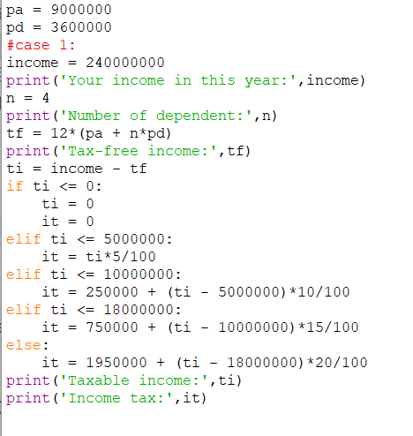

Case 2:

Your income of this year: 440000000
Number of dependent: 4
Tax-free income: 280800000
Taxable income: 159200000
Income tax: 30190000

